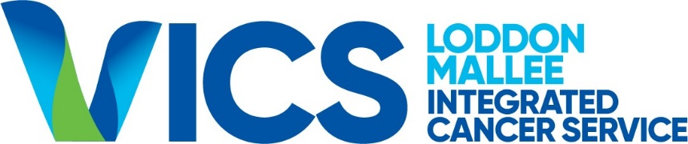

LMICS Funding Program Guidelines 2021

Background
The Loddon Mallee Integrated Cancer Service (LMICS) is one of the nine Victorian Integrated Cancer Services (ICS) funded by the Department of Health. It is governed by representatives from public, private and community health services, the Primary Health Network, consumers and Department of Health. Bendigo Health is the host agency for LMICS.
LMICS has allocated funding towards a grants program for organisations providing specialist and generalist cancer services to residents of the Loddon Mallee Region as defined in Figure 1 below. These grants target time-limited service improvement projects that cannot be funded within existing hospital resources.
Figure 1: Loddon Mallee Region
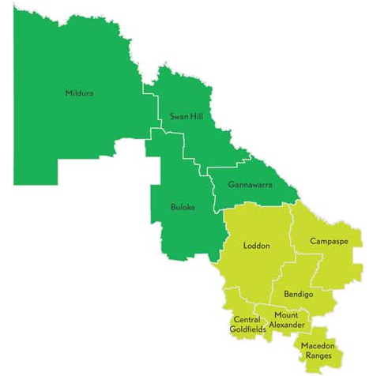
Source: http://www.rdv.vic.gov.au/victorian-regions/loddon-mallee

Funding Guidelines and Funding Availability
Three grants of up to $40,000 are being offered for 6-18 month long projects that address one or more of the following Action Areas from the 2021 Victorian Cancer Plan.
- 2.3 Improve access to services and care across the cancer screening pathway
- 2.4 Improve public awareness of cancer symptoms to help early detection
- 2.5 Support health professionals to improve early diagnosis of cancers and strengthen referral pathways to specialist care, including familial cancer centres for inheritable cancers
- 3.1 Implement the optimal care pathway for Aboriginal people with cancer
- 3.2 Implement and monitor performance against the optimal care pathways
- 3.3 Monitor and assess patients’ experiences of care in a culturally safe way
- 3.4 Implement service capability frameworks to support better, safer care
- 3.5 Support Victoria’s regional cancer centres to deliver appropriate, accessible, high-quality and safe cancer care close to home
- 4.1 Improve access to supportive care and help people manage some aspects of their own care
- 4.2 Implement the Victorian carer strategy 2018–2022 to recognise and support the important role of carers
- 4.3 Build workforce knowledge and skills in survivorship care across cancer care systems
- 4.4 Support early access to palliative care to manage symptoms and improve quality of life
- 4.5 Expand end-of-life care and palliative care skills and advance care planning education across the cancer workforce.

Evaluation Criteria
The following criteria will be considered when prioritising projects for funding:
- Extent to which project addresses one or more of the Action Areas listed in Item 2 above;
- Weight/extent of expected benefits from project;
- Extent to which the project will implement a sustainable change in service provision which can be specifically measured at commencement and completion;
- Value for money in term of benefit and also value of the in-kind and direct support provided by the applicant;
- Extent to which a committed project team and sponsor with appropriate skill sets to implement the project has been identified;
- Ability to comply with the requirements for funding;
- Compliance with the Bendigo Health Service Level Agreement.

In addition to the above criteria applications will not be considered if they:
- Apply to recurrent positions, non-sustainable initiatives or provision of direct patient care;
- Are inconsistent with the objectives of the LMICS, the Optimal Cancer Care Pathways www.cancer.org.au/ocp, the Victorian Cancer Plan 2016-2020 www2.health.vic.gov.au.or other state-wide initiatives and/or duplicate work in other ICS (please utilise LMICS staff to help ascertain this on your behalf);
- Are for the purpose of purchasing equipment for service delivery. Requests for funding for the purchase of equipment to support service change will be considered;
- Are not submitted by an eligible organisation. Eligible organisations support clients or carers in the Loddon Mallee Region of Victoria, have an ABN or are Incorporated and include:
  - Public or not for profit health services;
  - GP clinics;
  - Community or Aboriginal Controlled Community Health Services;
  - Non-profit organisations or peak bodies.

Application Process
To apply applicants must contact the LMICS Program Manager to discuss the project and receive the appropriate application forms and attachments.
Applications are due by 3:00 PM Australian Eastern Standard time 4 June 2021 by email to contracts@bendigohealth.org.au with ‘LMICS FUNDING PROGRAM 2021’ in the email header.
An email acknowledging receipt will be provided after the closing time.
Health services may submit more than one funding submission. These should be prioritised by the service. A separate application must be completed for every project.
Applications will be shortlisted by the LMICS Funding Evaluation Panel. The panel will provide recommendations to the LMICS Governance Group. Please note that further information or clarification may be sought.
It is anticipated that all applicants will be advised of the outcome of their submission in late June 2021.

Conditions of Funding & Reporting Requirements
The applicant must be prepared to sign a Service Level Agreement with Bendigo Health. A sample will be provided with the grant application forms.
The applicant acknowledges the following:
- The project will be conducted in accordance with the application and the conditions stipulated in the LMICS 2021 Funding Guidelines;
- Any deviation in the project from the original submission must be discussed with and agreed to by the LMICS Secretariat and documented in a Project Amendment Form supplied by LMICS;
- A detailed project plan (template to be provided by LMICS) will be submitted to LMICS within six weeks of the project commencing or as specifically agreed with LMICS;
- A project update report will be provided by the applicant as per the agreed Project Plan. LMICS may share these reports with its staff and advisory groups and with statewide ICS groups;
- A Final Report (including evaluation outcomes and expenditure report) will be submitted to the LMICS Directorate at the completion of the project (templates to be provided by LMICS). LMICS may share these reports with its staff and advisory groups and with statewide ICS groups;
- Information on the project, including any tools/resources developed, will be made available on the LMICS website to enable information sharing for the benefit of cancer patients and carers.

Fund Release Schedule
The funds release schedule will be in accordance with Bendigo Health policy and negotiated with the successful applicants. Applicants will need to provide a valid tax invoice for payment upon the completion of payment milestones to the satisfaction of LMICS.

Summary Information
Activity | Date
Invitation issued | 3/5/2021
End of period for questions or requests for information | N/A
Closing Time | 3:00 pm Australian Eastern Standard Time  3/6/2021.
Submission method | By email to contracts@bendigohealth.org.au with ‘LMICS FUNDING PROGRAM 2021 in the email header.
Intended completion of evaluation | 20/6/2021
Intended notification of outcome of application and issuing | 20/6/2021
Intended commencement of services | 30/6/2021

For further information on the LMICS Funding Program please contact Ilana Solo on:
Phone: 0416 084 018
E-mail: isolo@bendigohealth.org.au

LMICS funding program 2021 Round 1 Application

- APPLICANT DETAILS:

  - Lead applicant (must be an eligible organisation):
Click here to enter text.

  - ABN of Lead Applicant:

  - Street and Postal Addresses of Lead Applicant:

  - Name and contact details for this application:

Name: Click here to enter text.

Telephone/Mobile number(s): Click here to enter text.

Email address:

  - Please list any additional organisations and/or relevant individuals to be involved in this project:
Click here to enter text.

  - Current Insurance details
Bendigo Health as fund holder for LMICS requires appropriate insurance provisions for funding contemplated under this application process. Please provide details of all relevant insurances maintained by the applicant in the table below:
Name of insurance companies:

Policy type (eg public liability, professional indemnity, etc): Click here to enter text.

Policy number(s):
Expiry dates:

Limit of liability: Click here to enter text.
Relevant exclusions: Click here to enter text.
(Note: Successful applicants will be required to provide copies).
- PROJECT DESCRIPTION AND METHODOLOGY
  - Project title (less than 15 words)
Click here to enter text.
  - Describe the project objectives (up to 500 words). Please ensure your response is Specific, Measurable, Realistic and Timed.

  - Indicative summary project plan summary based on a commencement date of 30 June 2021: (Applicants do not need to complete all lines in the table):
Task/Activity | Completion Date:
Click here to enter text. | Click here to enter a date.
Click here to enter text. | Click here to enter a date.
Click here to enter text. | Click here to enter a date.
Click here to enter text. | Click here to enter a date.
Click here to enter text. | Click here to enter a date.
Click here to enter text. | Click here to enter a date.
Click here to enter text. | Click here to enter a date.
Click here to enter text. | Click here to enter a date.
Click here to enter text. | Click here to enter a date.

  - Please list the project benefits and how they will be measured. (Applicants do not need to complete all lines in the table):

Benefit | Describe how this will be measured
Click here to enter text. | Click here to enter text.
Click here to enter text. | Click here to enter text.
Click here to enter text. | Click here to enter text.
Click here to enter text. | Click here to enter text.
Click here to enter text. | Click here to enter text.
Click here to enter text. | Click here to enter text.
Click here to enter text. | Click here to enter text.
Click here to enter text. | Click here to enter text.
Click here to enter text. | Click here to enter text.
Click here to enter text. | Click here to enter text.

- RELEVANCE TO STRATEGIC PLAN PRIORITY AREAS

  - The applicant must describe how the project will address one or more of the grant targeted priority areas in the table below:

Targeted priority area | How the project will address this priority area
 | Click here to enter text.

- TOTAL FUNDING REQUESTED (in $AUS and exclusive of GST)

  - Summary of funding requested:

Description | $ in kind/ funded by applicant | $ LMICS funding requested | $ Total | Comment (if needed)
A) Operational Expenditure
Staff
Contractors
Volunteers
Other - Stakeholder consultations
Other - Travel
Other -
Other -
B) Capital Expenditure
Equipment – IT desk stationary
TOTAL

  - Indicative payment schedule based on proposed milestones and basic project plan and requirements for funding and reporting. (Applicants do not need to complete all lines in the table):

No. | Milestone | Payment %
1 | Signing of contract | 25%
3 | Final Report Delivered | 75%

- Any Other Matters

Click here to enter text.

- APPLICANT’S DECLARATION AND COMPLIANCE SUMMARY

  - Compliance with the Bendigo Health Service Level Agreement sample at Attachment 1.

Choose an item.

Comment (if required): Click here to enter text.
  - Declaration

I certify that the information in this application is accurate and has been compiled in accordance with the LMICS Funding Program Guidelines 2021. I understand that project outputs will be published on the LMICS website.
Name: Click here to enter text.
Position: Click here to enter text.
Organisation: Click here to enter text.
Signature: Click here to enter text. | Date

CEO, Executive Director or authorised representative declaration
I fully support this application and agree in principle to the changes/impact it may have on our organisation. I understand that project outputs will be published on the LMICS website.
Name: | Click here to enter text.
Position: | Click here to enter text.
Organisation: | Click here to enter text.
Signature: | Click here to enter text. Date:
Health service priority ranking:  NOTE: If more than one application is being submitted, each application must be submitted separately and ranked accordingly ie you can only have one ‘First’ priority ranking etc. | First

APPLICANTS SUBMISSION GUIDE:

- Obtain the Funding Guidelines, Application Form and sample Service Level Agreement.
- Understand the application process and allow sufficient time to complete the requirements.
- Know the closing time and format for providing submissions.
- Understand the targeted priority areas and funding availability.
- Understand the evaluation criteria for funding submissions.
- Ensure responses provide sufficient information.
- Understand the funding and reporting requirements.
- Ensure all relevant fields are completed in the application form.
- Ensure applications are signed appropriately.

Volunteers should be costed at $30/hour

